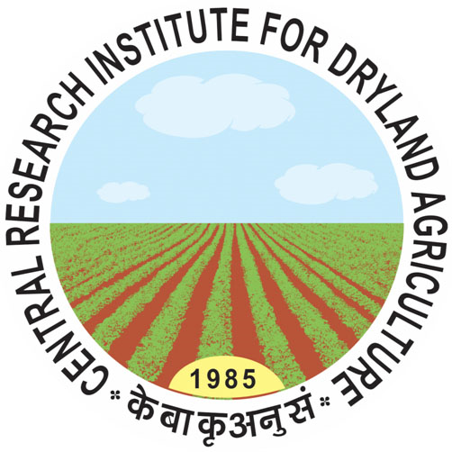 | Central Research Institute for Dryland Agriculture  (Indian Council of Agricultural Research)  Santoshnagar, Saidabad PO, Hyderabad - 500 059 (AP) | 

Affix recent passport size photograph
APPLICATION
Name of the Position ………………………………………………………
Discipline ………………………………………………………
1. | Name of Candidate  (In Block Letters)
2. | Father’s/Husband’s Name
3. | Date of birth and age
4. | Address for  Correspondence  with PIN code
5. | Telephone / Mobile number
6. | E-mail address
7. | Educational Qualifications
Qualification |  | University |  | Discipline | % of marks | Passing year

8. Details of Experience

Declaration
I do hereby declare that all the statement made in this application are true, complete and correct to the best of my knowledge and belief I understand and agree that in the event of any information being found false or incorrect/incomplete or ineligibility being detected at any time before or after selection/interview, my candidature is liable to be rejected.

(Signature of the Candidate)
Date: ………………………………
Place: ……………………………..

